Heap Sort

//Heap Sort

#include<stdio.h>

#include<conio.h>

void deletemax(int a[],int last);

void insert(int a[],int pos);

void heapsort(int a[]);

void adjust(int a[],int last);

int i,n,last,item,pos;

int a[20]={10,9,5,8,23,2,1,6,7,11};

void deletemax(int a[],int last)

{

int x;

x=a[1];

a[1]=a[last];

a[last]=x;

adjust(a,last-1);

}

void insert(int a[],int pos)

{

int i=pos,item=a[pos];

while((i>1) && (a[i/2]<item))

{

a[i]=a[i/2];

i=i/2;

}

a[i]=item;

}

void adjust(int a[],int n)

{

int j=2;

int item=a[1];

while(j<=n)

{

if((j<n)&&(a[j]<a[j+1]))

{

j=j+1;

}

if(item>=a[j])

{

break;

}

a[j/2]=a[j];

j=2\*j;

}

a[j/2]=item;

}

void heapsort(int a[])

{

int i;

for(i=1;i<=9;i++)

{

insert(a,i);

}

for(i=9;i>=1;i--)

{

deletemax(a,i);

}

}

void display(int a[])

{

int i;

for(i=1;i<=9;i++)

{

printf("%d ",a[i]);

}

}

void main()

{

printf("\n");

for(k=1;k<=n;k++)

{

scanf("%d",&a[k]);

}

\*/

clrscr();

heapsort(a);

printf("Elements are : \n ");

display(a);

getch();

}

OUTPUT:

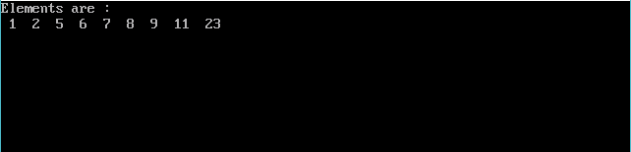

Shell Sort

//Shell Sort

#include<stdio.h>

#include<conio.h>

void main()

{

int num[10],a,n,temp,count;

int i,d,j;

clrscr();

printf("How many numbers you want to enter?\n");

scanf("%d",&n);

printf("Enter %d numbers\n",n);

for(i=0;i<n;i++)

{

scanf("%d",&num[i]);

}

printf("The numbers in ascending order using shell sort are :\n");

//Shell Sort

d=(n+1)/2;

for(d=n/2;d>0;d/=2)

{

for(j=d;j<n;j++)

{

for(i=j-d;i>=0;i-=d)

{

if(num[i+d]>=num[i])

{

break;

}

else

{

temp=num[i];

num[i]=num[i+d];

num[i+d]=temp;

}

}

}

printf("\nGap = %d\n",d);

for(i=0;i<n;i++)

{

printf("%d",num[i]);

printf("\t");

}

}

getch();

}

OUTPUT:

